The Course Project

**Plagiarism and cheating will not be tolerated for this individual and independent project assignment. All submissions will undergo a thorough plagiarism check. Sharing your work with other students, copying others' work, or using AI tools such as ChatGPT is strictly prohibited. Any instances of plagiarism or cheating will result in a grade of 0 for the entire project submission.**

The course project consists of four parts. Parts 1, 2, 3 require the use of the project data zip file, while parts 4 require the use of a text file generated from part 3.

Part 1:

Develop a Mapper and Reducer application to calculate the *average* of *wind direction* (degree) for *each observation month* *from each year* (e.g. 195001) from NCDC records (note: 999 indicates missing value, and [01459] indicate good quality value).

Decompressing all the .gz files

gunzip *.gz

Change the execution permission of the Python files:

chmod +x mapper1.py reducer1.py

Test the two Python files locally before running them using Hadoop.

echo "0062038040999991927123106004+49933-006300FM-12+005099999V0202001N00931220001CN0200001N9+00721+99999101701ADDAA199001091AY161999GF104991041011012501001001MD1810061+9999" | /home/student6/Project/mapper1.py

echo "0067011990999991950051507004+68750+023550FM-12+038299999V0203301N00671220001CN9999999N9+00001+99999999999" | /home/student6/Project/mapper1.py | sort -k1,1 | /home/student6/Project/reducer1.py





Making a directory and Copying the sample data to HDFS

hdfs dfs -mkdir /home/6student6/Project

hdfs dfs -copyFromLocal /home/student6/Project/ProjectData /home/6student6/Project/

Execute the mapper and reducer using Hadoop streaming.

hadoop jar hadoop-streaming-2.7.3.jar -file /home/student6/Project/mapper1.py -mapper /home/student6/Project/mapper1.py -file /home/student6/Project/reducer1.py -reducer /home/student6/Project/reducer1.py -input /home/6student6/Project/ProjectData/ -output /home/6student6/Project/Part1_Output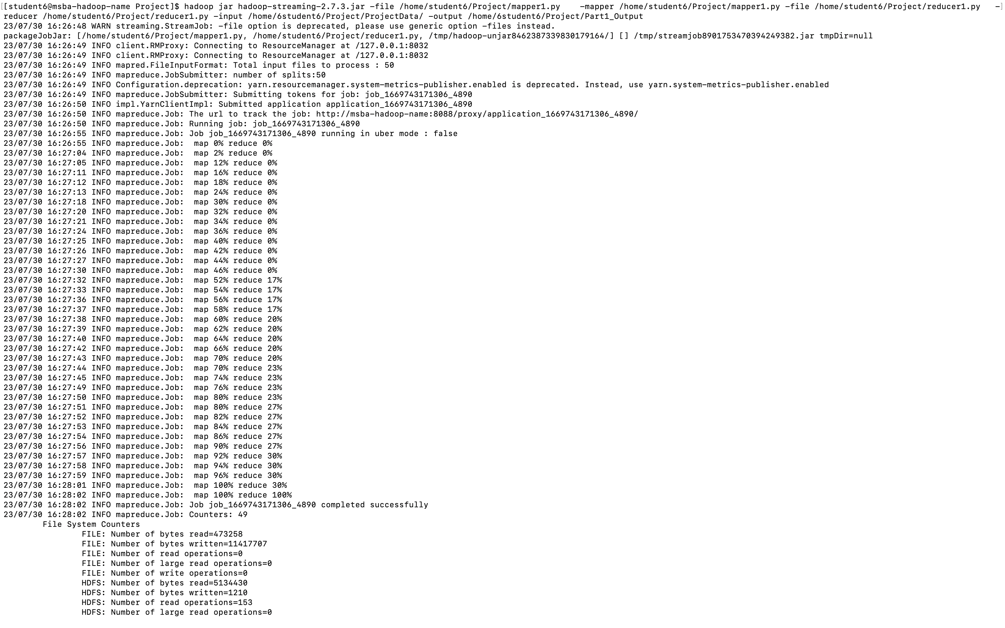

Printing out the final output:

hdfs dfs -ls /home/6student6/Project/Part1_Output/

hdfs dfs -cat /home/6student6/Project/Part1_Output/part-00000

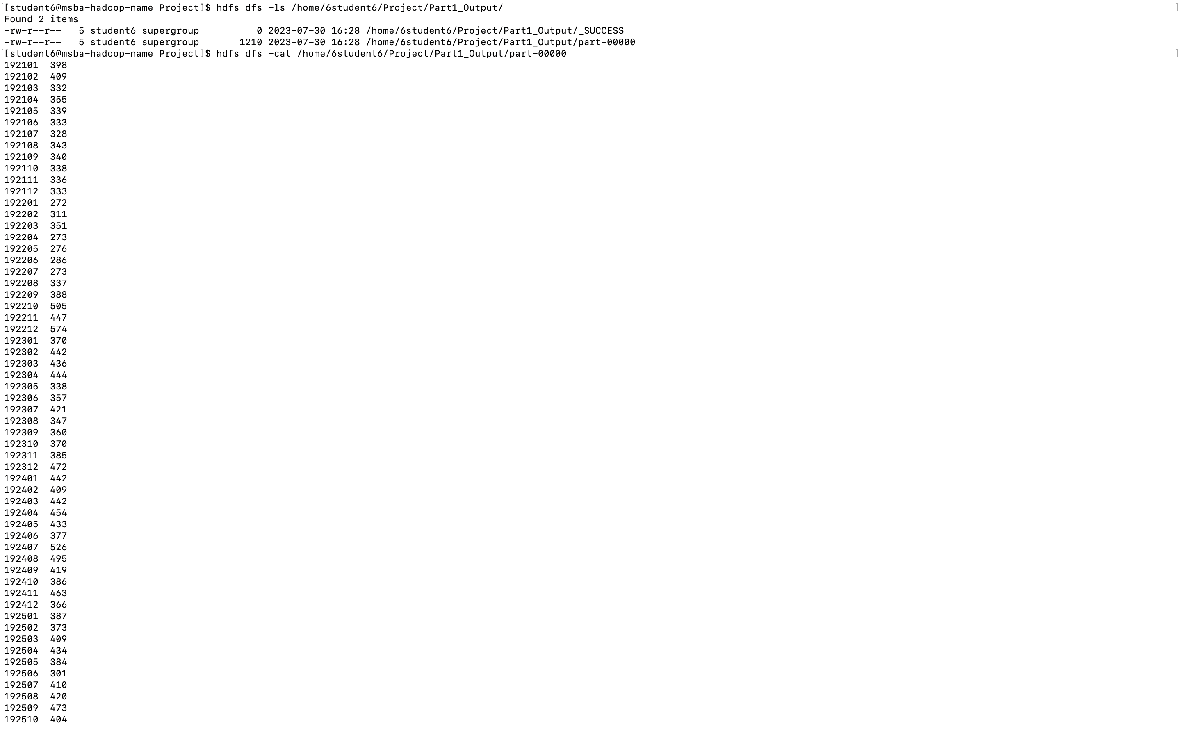

Part 2:

Develop a python application that can be implemented in PySpark to calculate the *range* (the difference between max and min values) of *sky ceiling height* (meters) for *each USAF weather station ID* from NCDC records (note: 99999 indicates missing value, and [01459] indicate good quality value).

Executing the .py file in PySpark:

spark-submit --master local PySpark_SkyCeiling.py

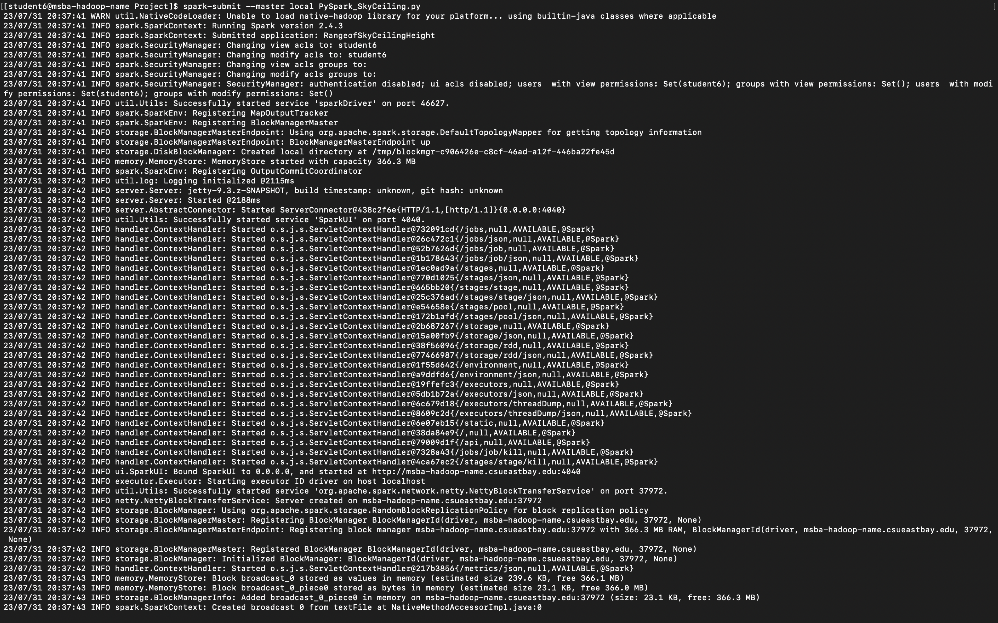

Verifying and printing the output files:

hdfs dfs -ls /home/6student6/Project/outputpyspark_SkyCeilingRange/

hdfs dfs -cat /home/6student6/Project/outputpyspark_SkyCeilingRange/*

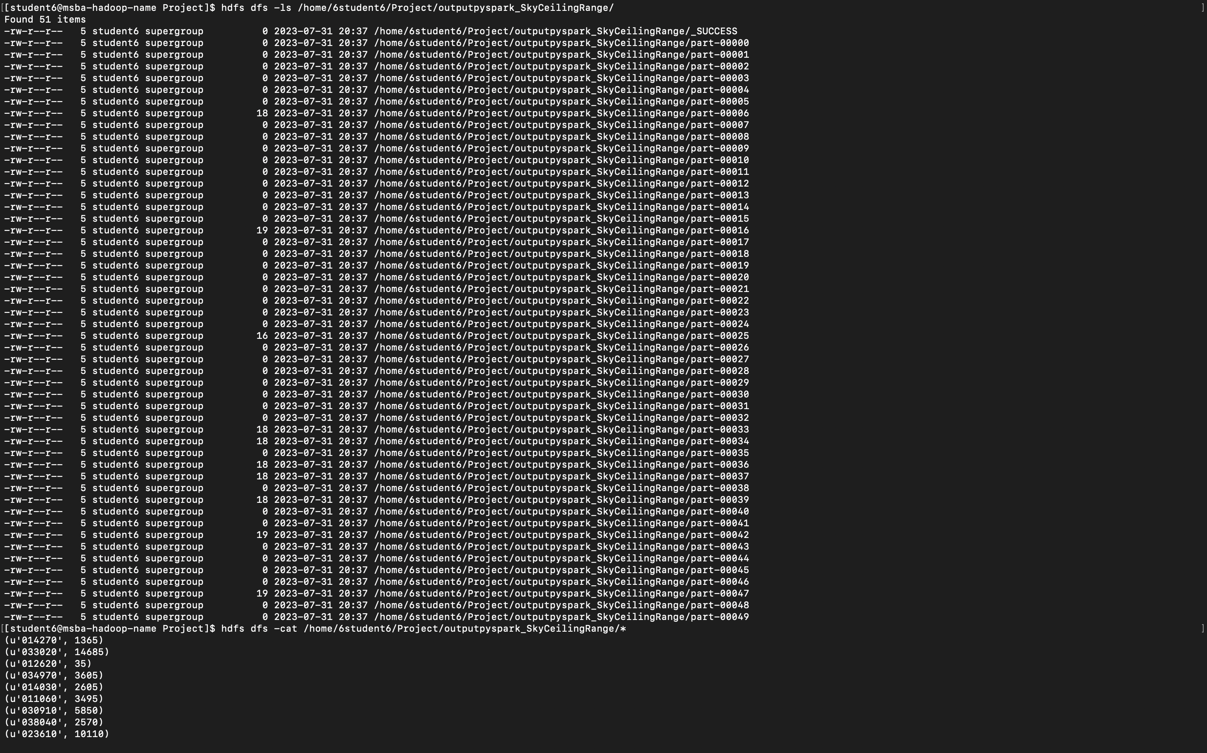

Part 3:

Develop a Mapper and Reducer application to retrieve *USAF weather station ID* and *visibility distance (meters)* from NCDC records (note: 999999 indicates missing value, and [01459] indicate good quality value) and then *write* the USAF weather station ID and visibility distance data into *a text file*.

python MRjob_Visibility.py -r local ProjectData/*

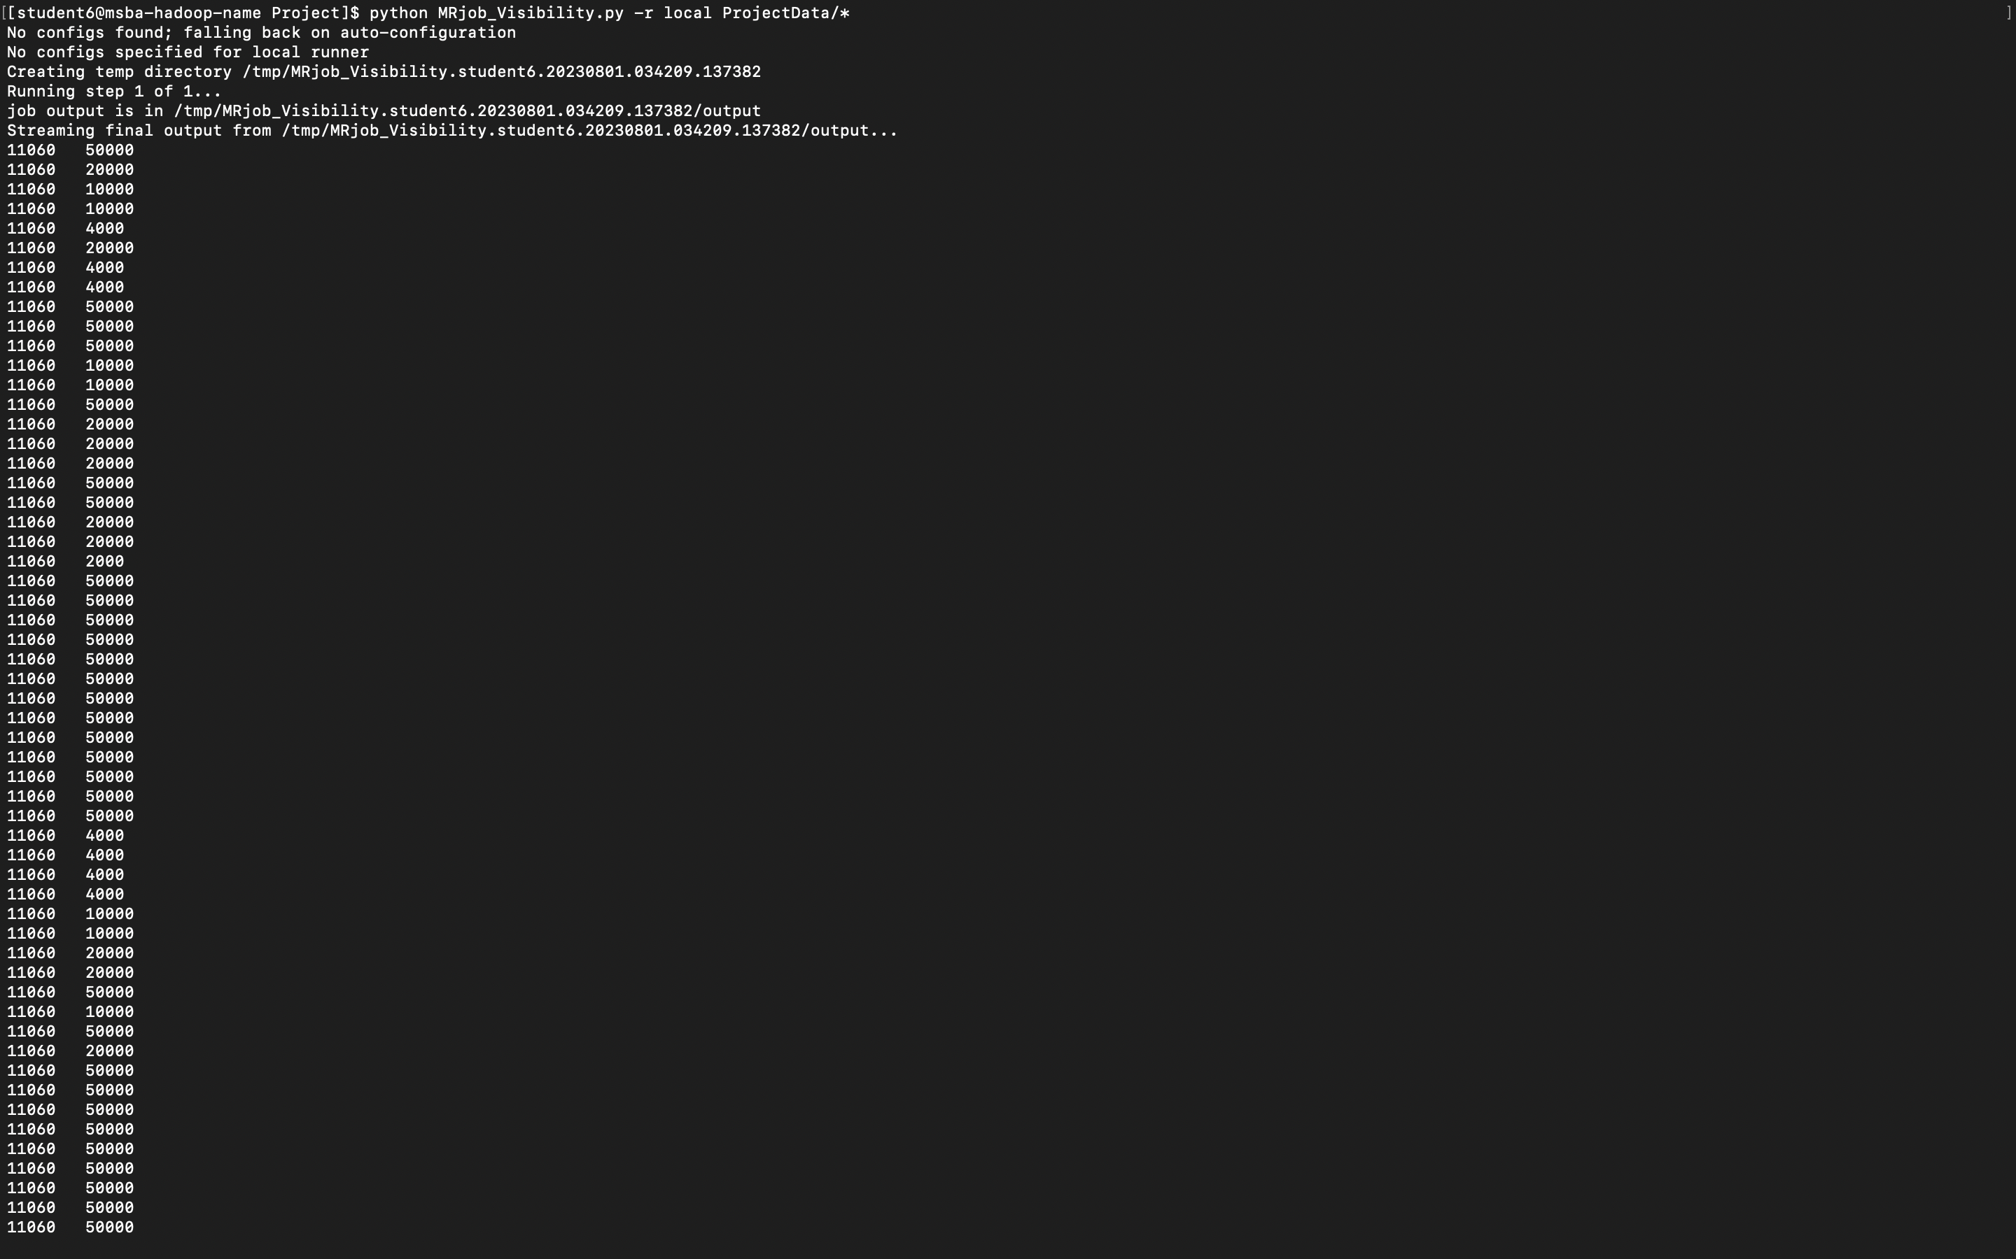

Creating a text file for the above output:

python MRjob_Visibility.py -r local ProjectData/* > Visibility_Output.txt

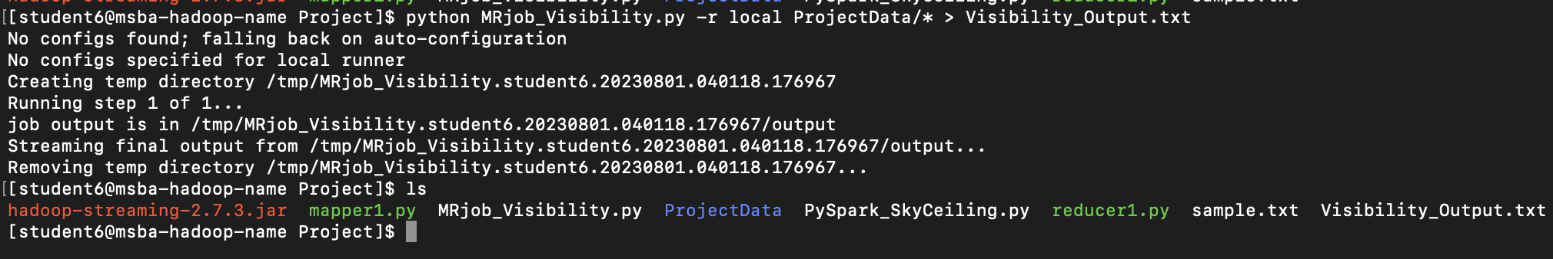

Part 4:

Load the text file into Pig and get the range of *visibility distance* for each USAF weather station ID.

records = LOAD 'Visibility_Output.txt'

AS (usaf_id: int, visibility: int);

DUMP records;

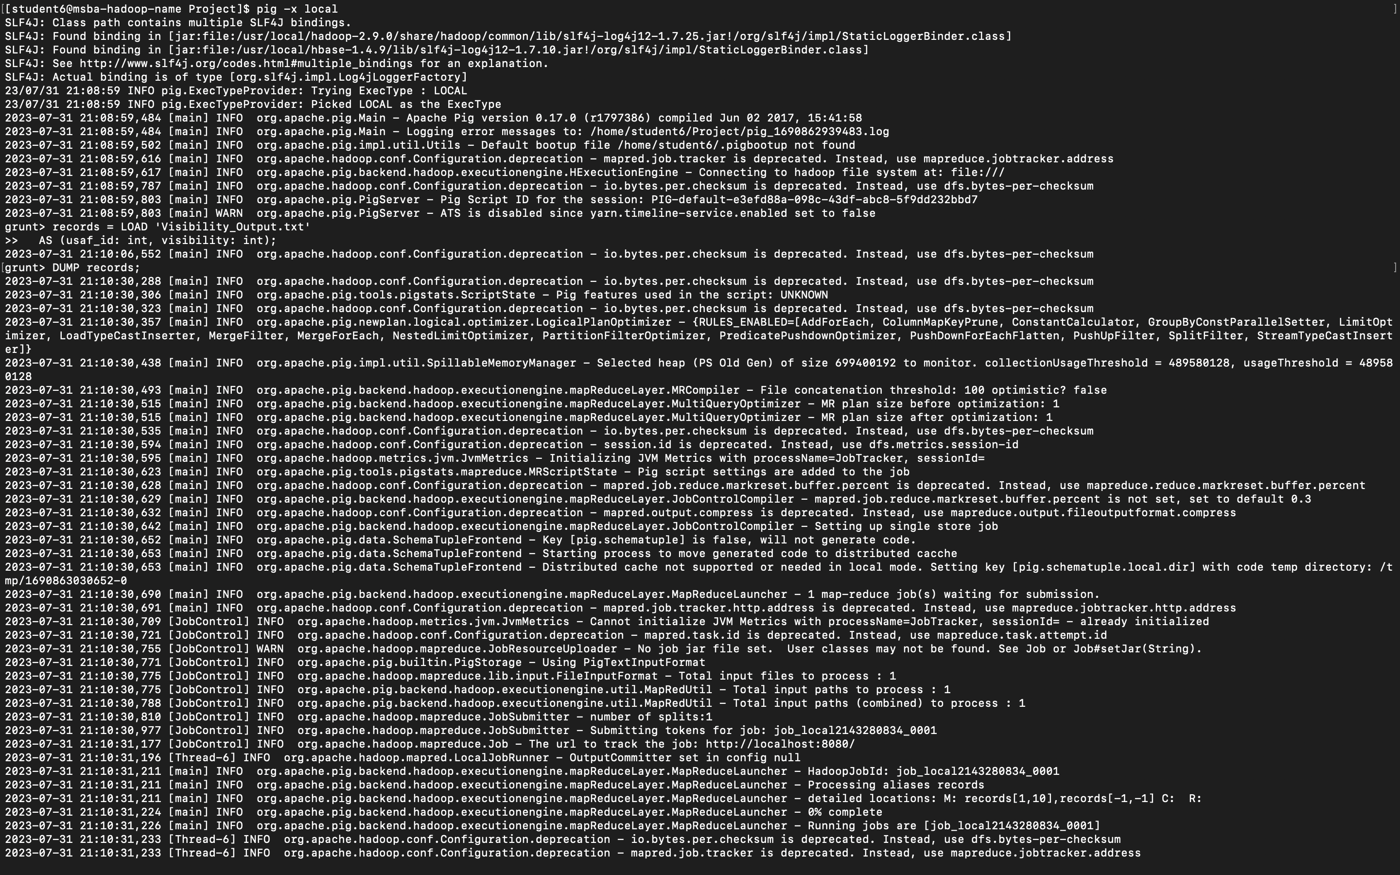

DESCRIBE records;

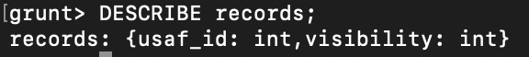

filtered_records = FILTER records BY visibility != 999999 AND

usaf_id != 999999;

DUMP filtered_records;

grouped_records = GROUP filtered_records BY usaf_id;

DUMP grouped_records;

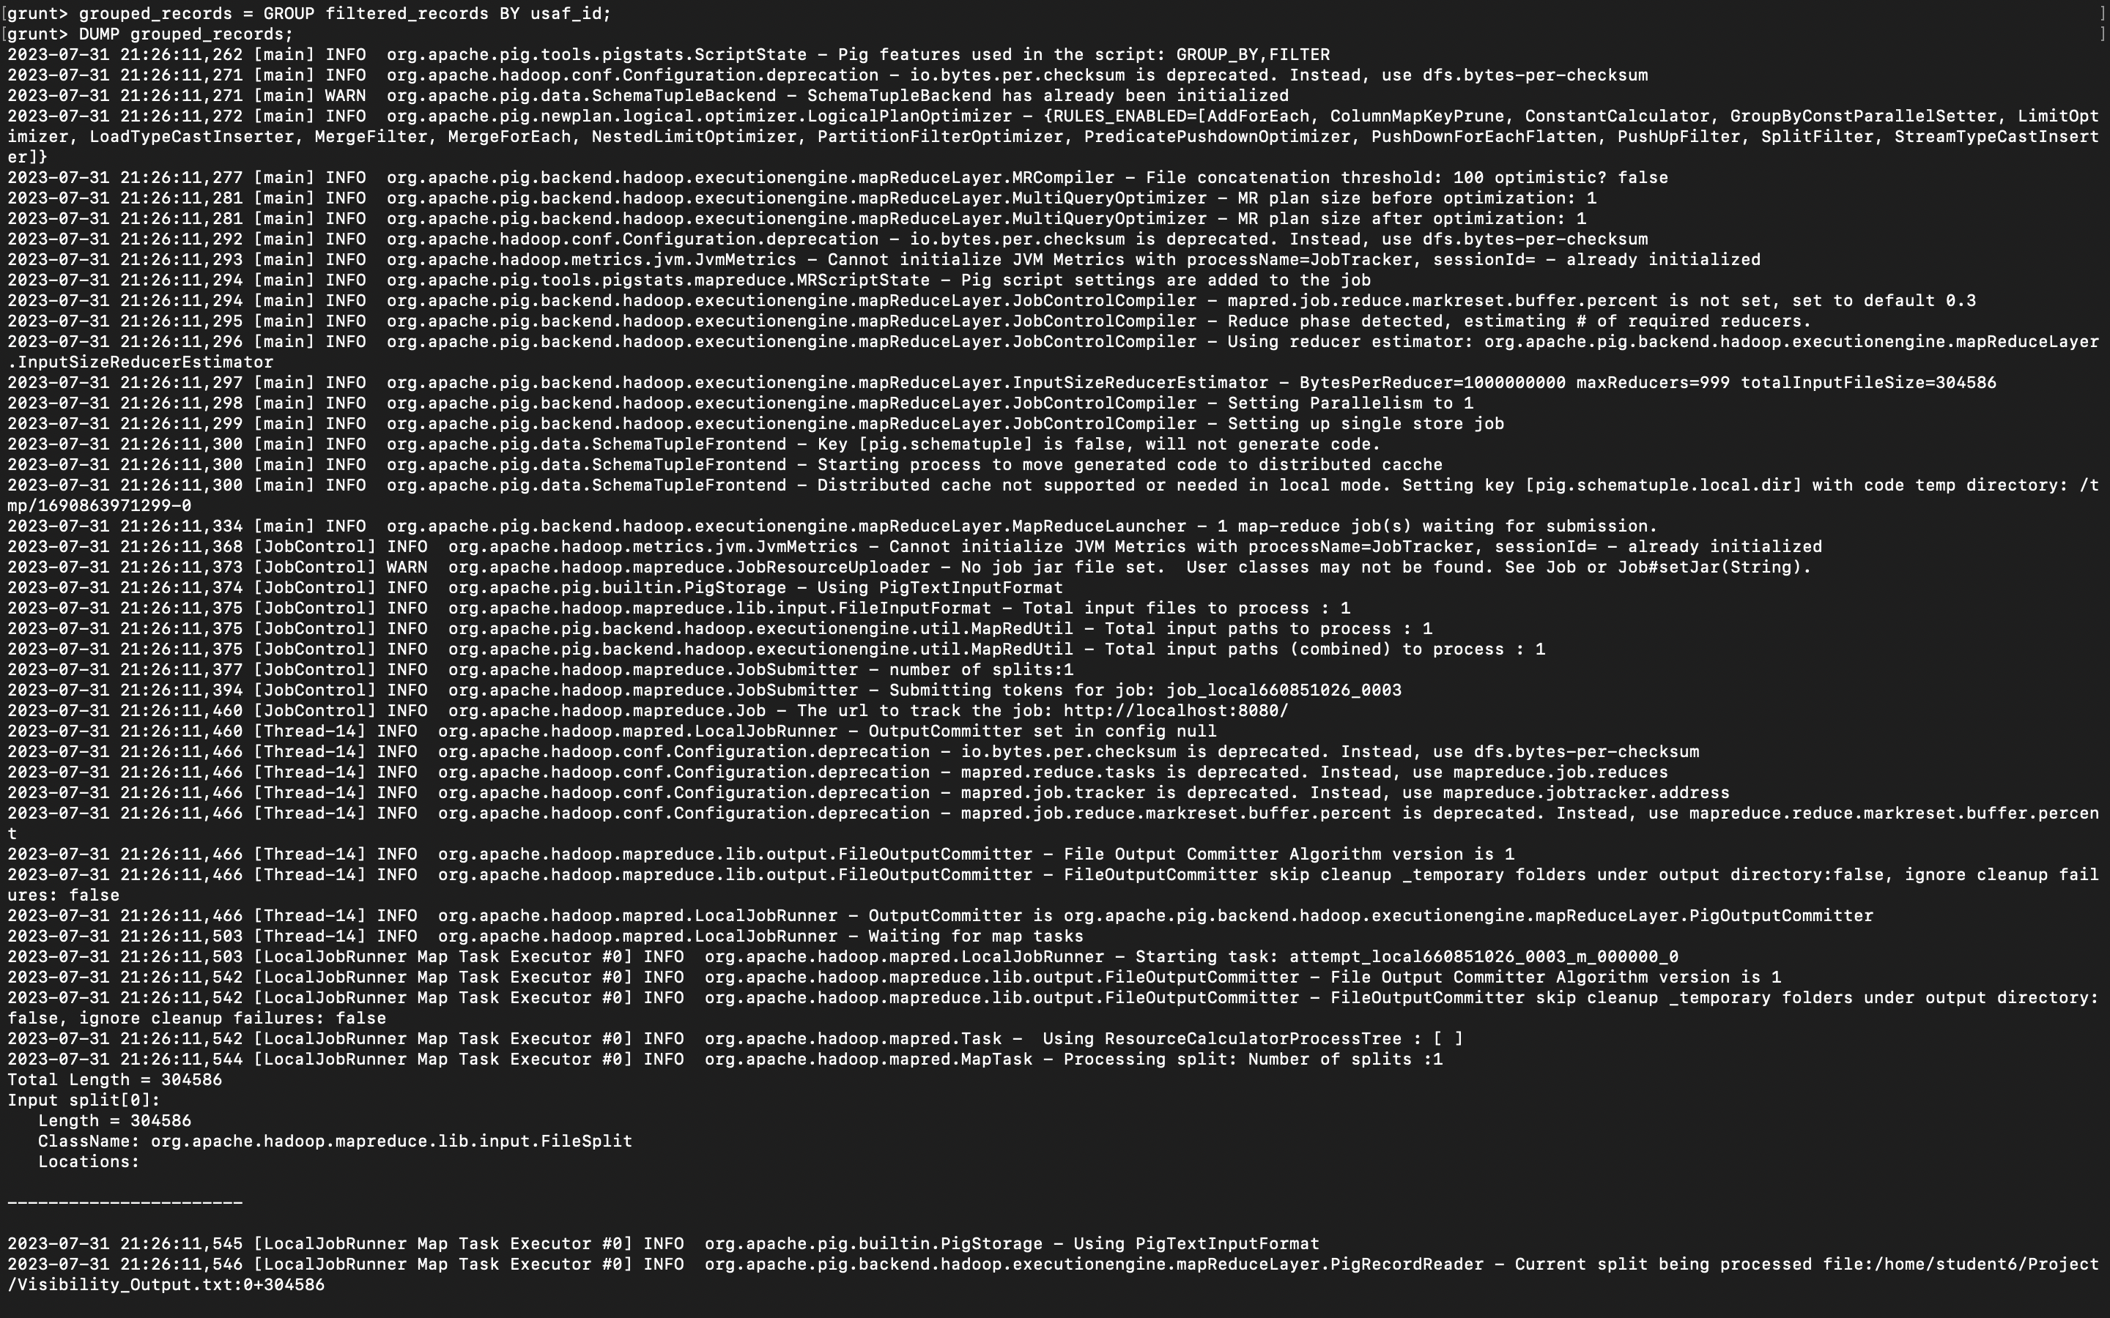

range_visibility = FOREACH grouped_records {

range = MAX(filtered_records.visibility) - MIN(filtered_records.visibility);

GENERATE group AS usaf_id, range;

}

DUMP range_visibility;

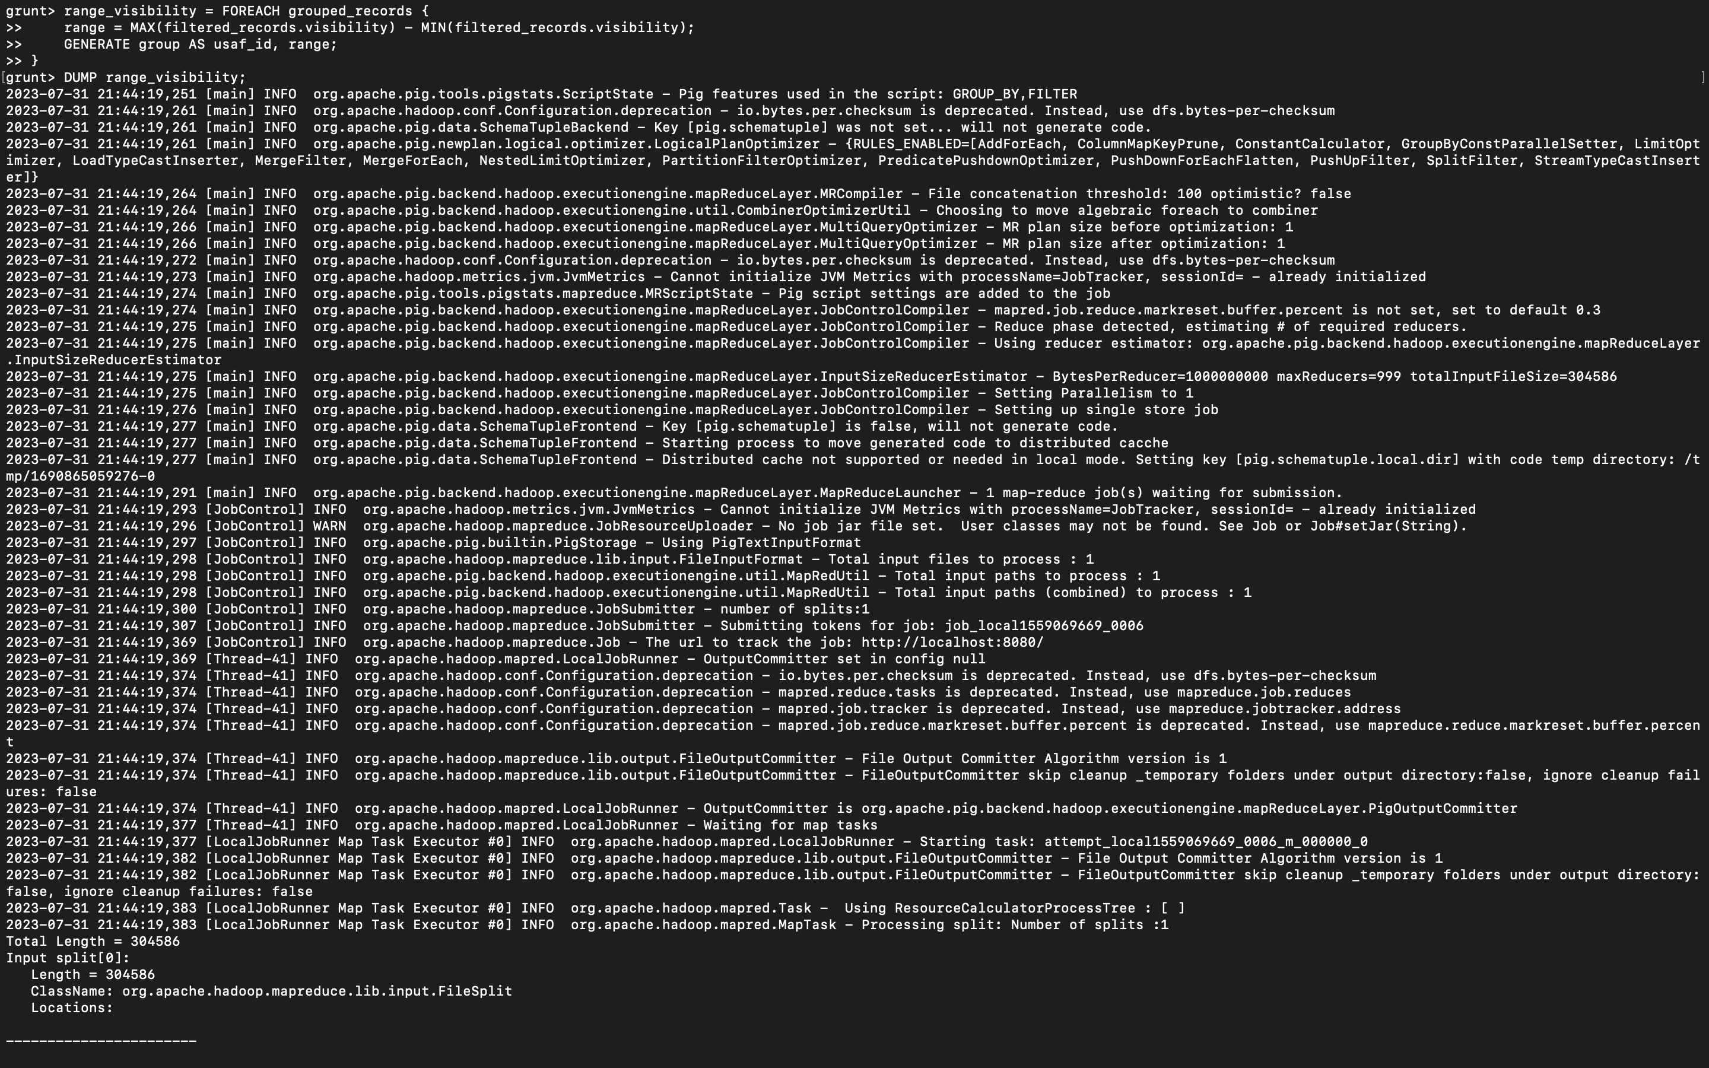

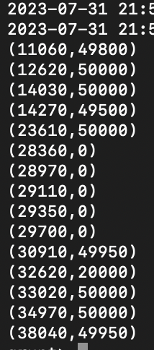

ILLUSTRATE range_visibility;

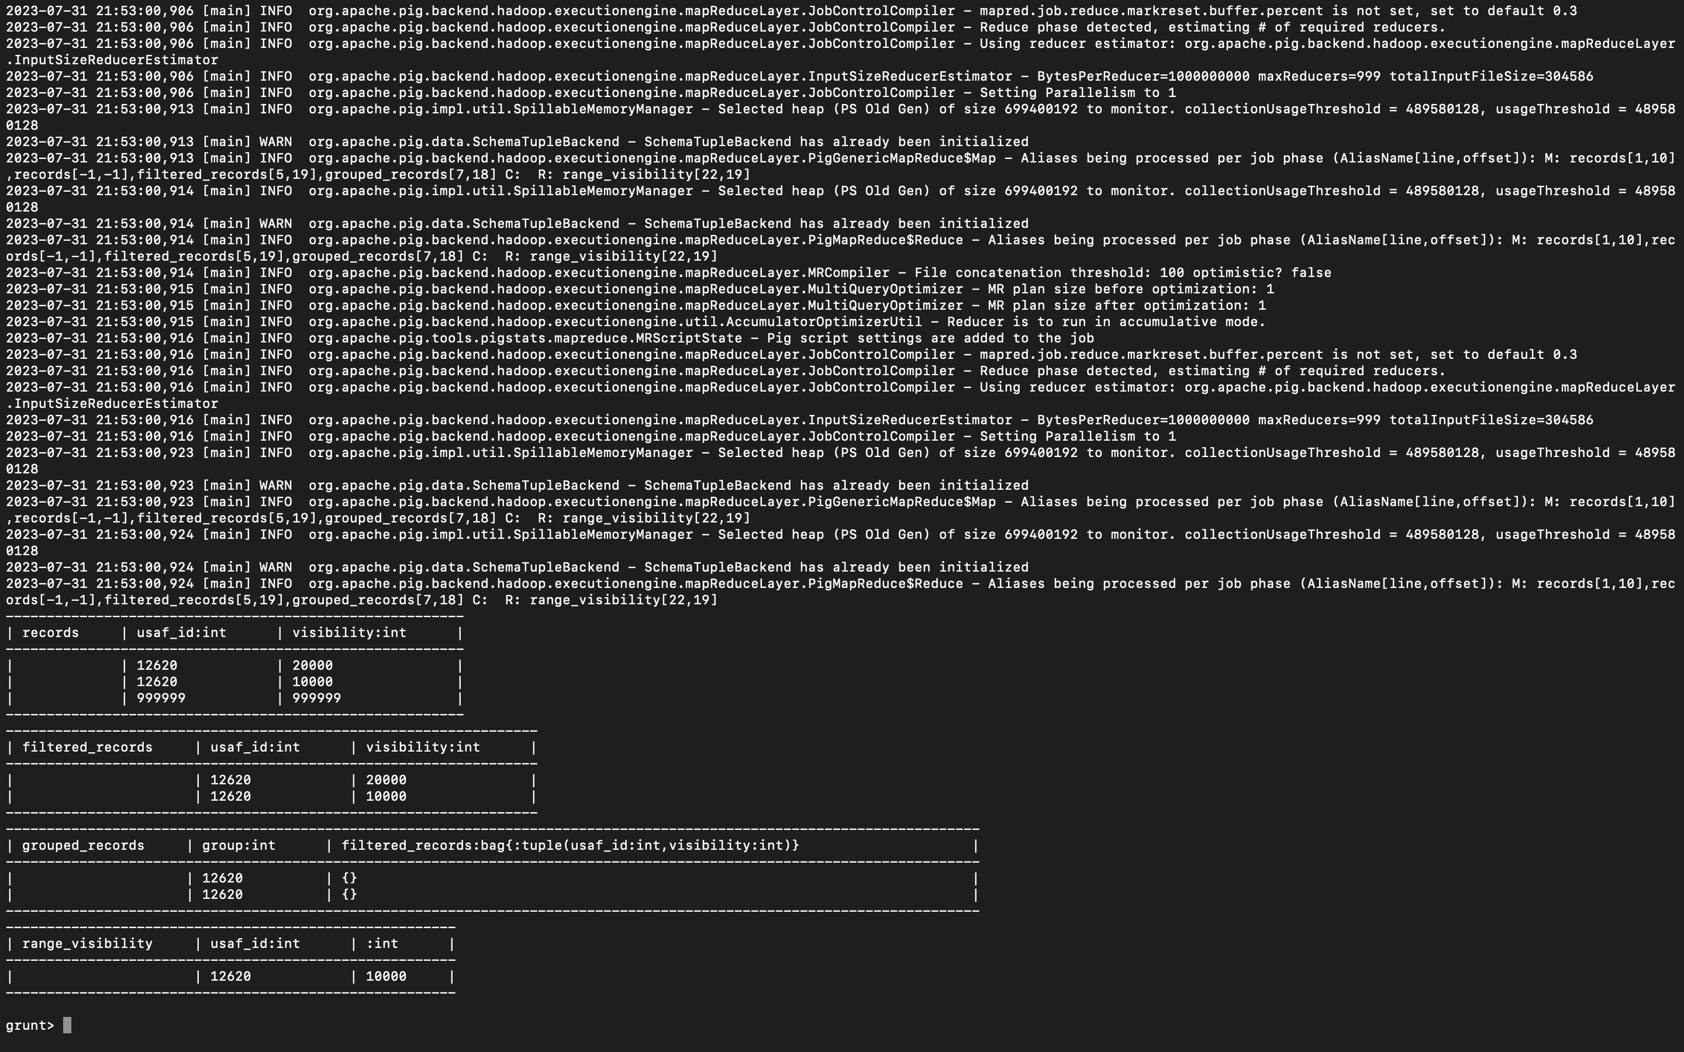

Part 5:

Load the text file into Hive and get the average *visibility distance* for each USAF weather station ID.

DROP TABLE IF EXISTS avg_visibility_6;

CREATE TABLE avg_visibility_6 (usaf_id INT, visibility INT)

ROW FORMAT DELIMITED

FIELDS TERMINATED BY '\t';

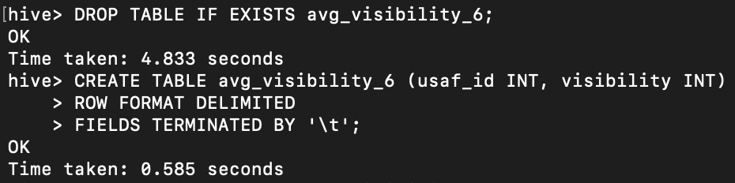

LOAD DATA LOCAL INPATH 'Visibility_Output.txt'

OVERWRITE INTO TABLE avg_visibility_6;

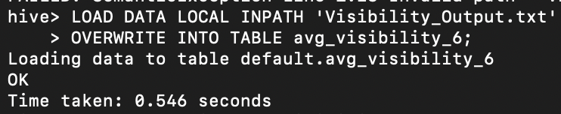

SELECT usaf_id, AVG(visibility)

FROM avg_visibility_6

WHERE visibility != 999999 AND usaf_id != 999999

GROUP BY usaf_id;

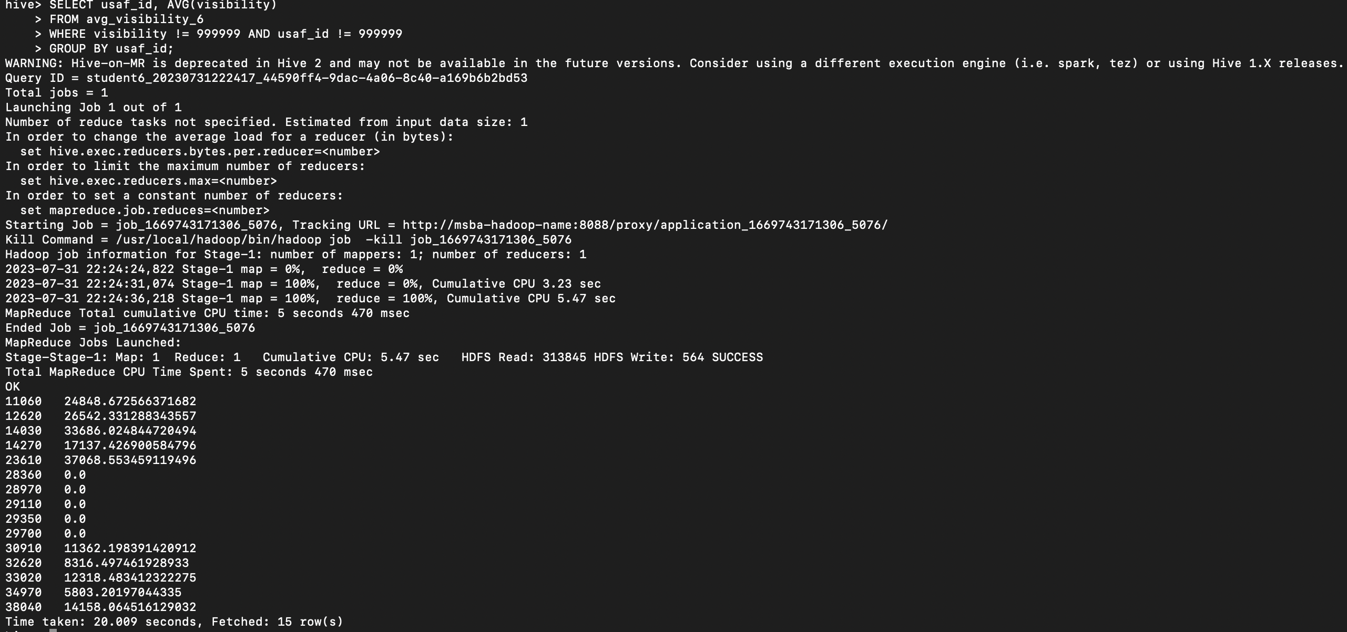

**You need to turn in:**

**1)** Part 1:

a. *if you are using JAVA to develop the Mapper and Reducer applications:* the three java files (mapper, reducer and main);

b. *if you are using Hadoop streaming jar and developing two python programs (mapper python file and reducer python file)*: the two python files (mapper and reducer);

c. *if you are using mrjob library and developing one python program with two functions:* the python file (with the mapper and reducer functions);

2) Part 2: the python program you developed;

3) Part 3: refer to Part 1; and the text file created;

**4)** the commands from converting java files into a Jar file to running the Jar file in Hadoop, or the commands to execute the python files in Hadoop and in Spark, all commands in Pig and Hive;

**5)** the step by step commands and screenshots of solutions from all the parts;

The original dataset for this project is available on Blackboard.